**DESIGN DIAGRAMS FOR ONLINE CLOTH MART**

TEAM MEMBERS

Kshitiz Mohan

Disha Saxena

Stuti Agarwal

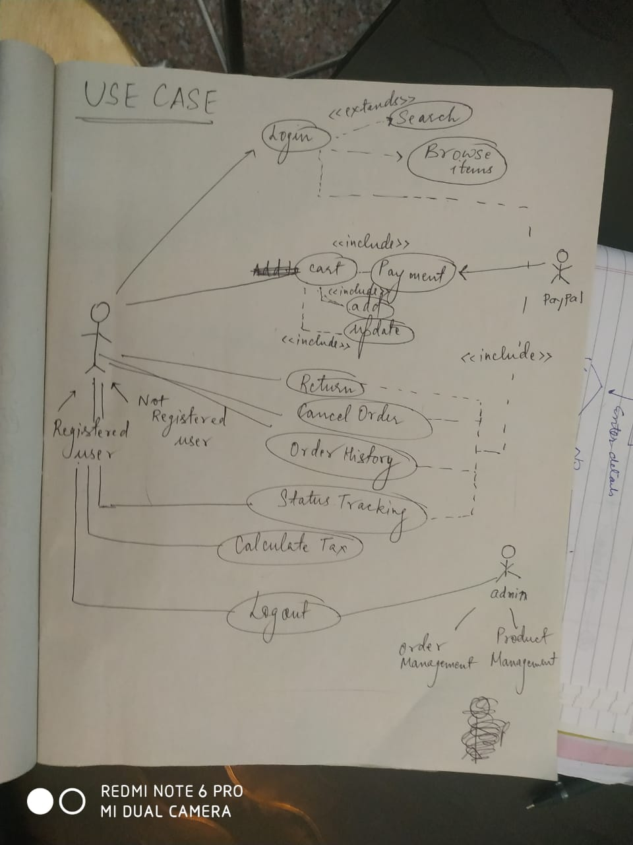

1. USE CASE

2.SERVICE CLASS DIAGRAM

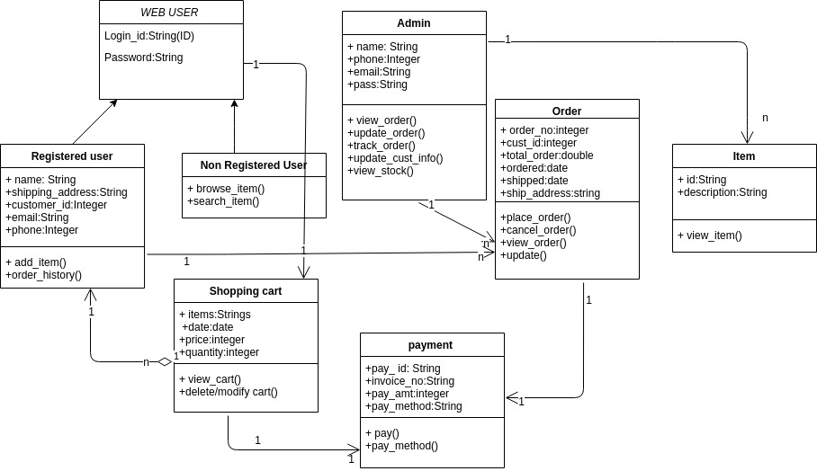

3.ACTIVITY DIAGRAM-USER SIDE

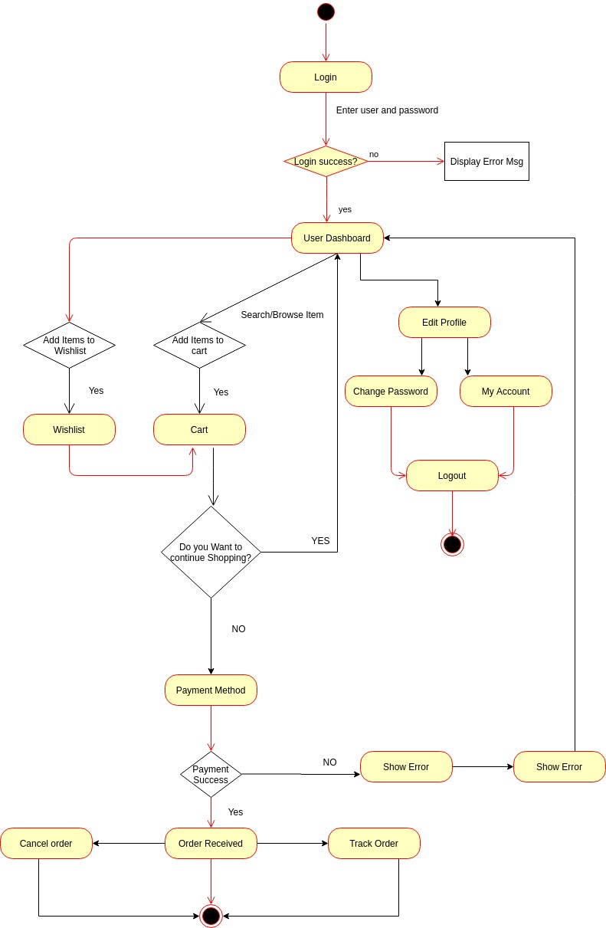

4.ACTIVITY DIAGRAM-ADMIN SIDE

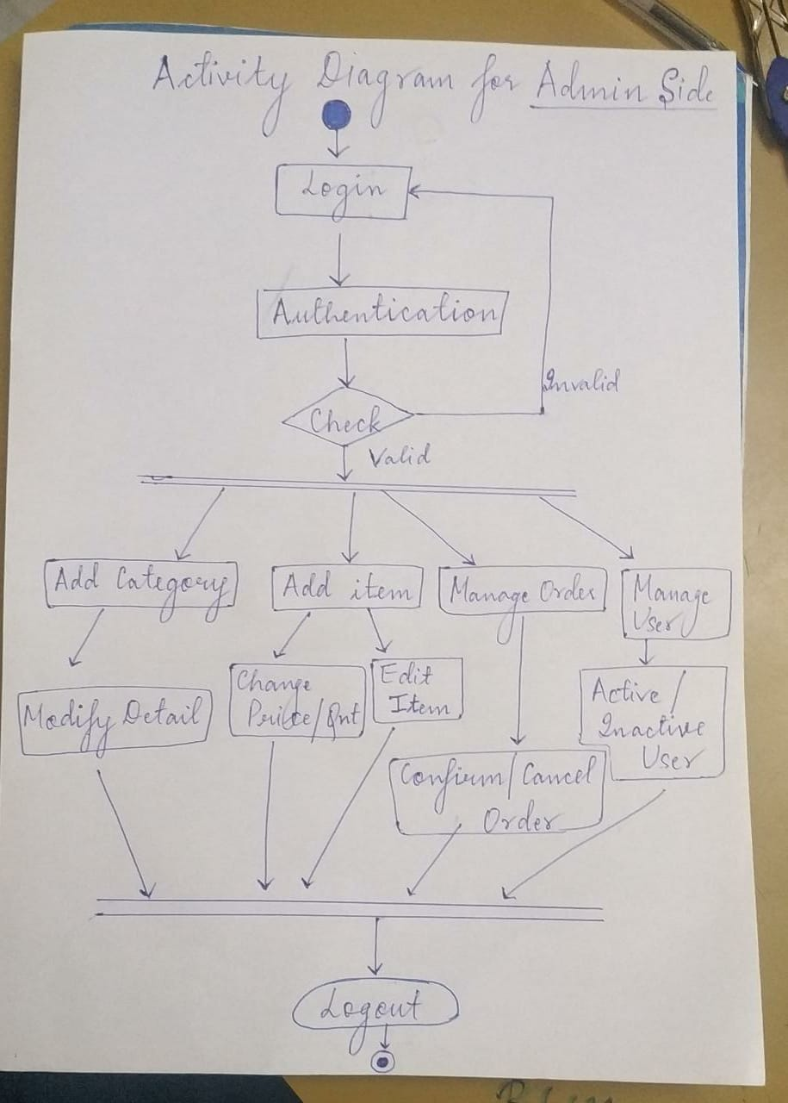

5.SEQUENCE DIAGRAM

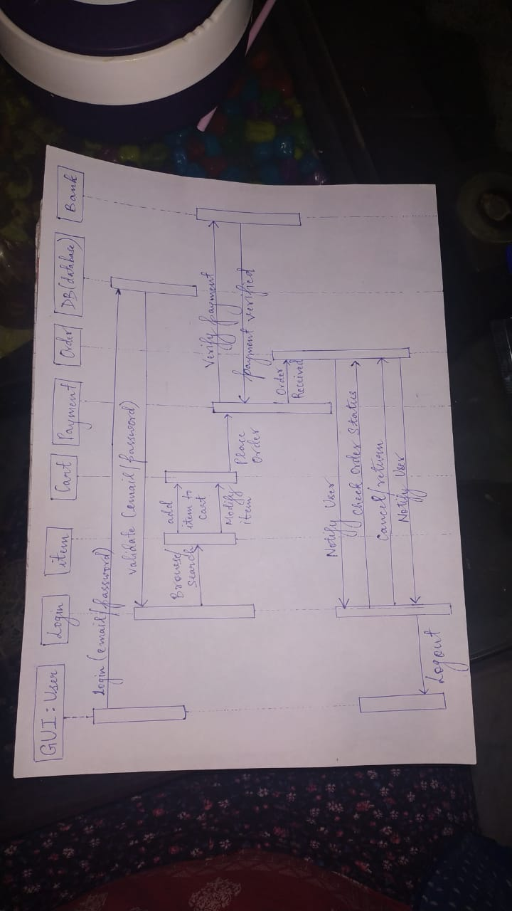

6.DOMAIN MODEL DIAGRAM

